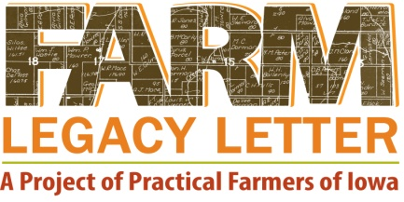 Template

Date:
To my future generations:

SECTION 1: The farm basics (from Activity 1) (the “nuts and bolts”)

My farm is acres located:

I have owned the farm since:

Enterprises on the farm include:

We used to raise these enterprises on the farm:

My farm has changed over the years in the following ways:

SECTION 2: Strongest memories and events (from Activity 2) (the “heart and soul”)

My strongest memories of the farm are:

I remember best these sights/smells/sounds/touches/tastes:

These events stand out as particularly important about the farm:
SECTION 3: Goal setting (From Activity 3) (the “vision for the future”)

My number one goal for my farmland is:

This is my very top goal because:

The following goals are also my priorities (although not my top goal):

These are important goals for me because:

SECTION 4: Conclusion (the “parting gifts”) (last two questions from Activity 2)

It is important that my farm is managed like this:

30 years from now, I want people to remember this about my farm:

Lastly, I want to leave you with this information:

Signed: _________________________________________

