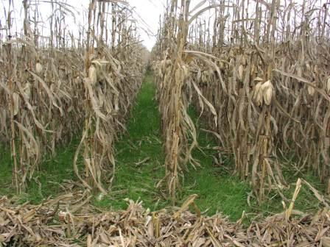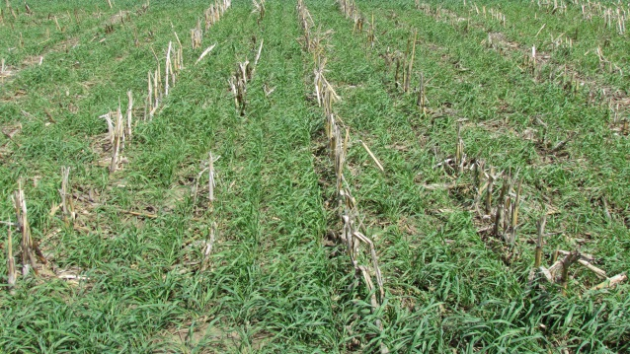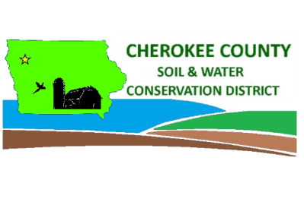Cover Crop and Soil Health Field Day

Featured Speakers:

* Nathan Anderson – Conservation Districts of Iowa Cover Crop Champion Commissioner
* Mike Henderson - District Conservationist with the Natural Resources Conservation Service for Cherokee and O’Brien Counties

**Cover Crop Benefits**

**Location: Anderson Farm**

**1950 520th St**

**Cherokee, Iowa 51012**

**Directions: 1 mile North of Highway 3 on M10 and ½ West on 520th St. South Side of the road.**

**April 9th at 1 p.m.**



* Reduce erosion even in no-till
* Reduce nitrate leaching
* Suppress winter annual and early season weeds



* Increase soil organic matter
* Improve soil health, quality, and productivity
* Add grazing and forage potential

Cherokee County SWCD

314 Lake St

Cherokee, IA 51012

Phone: 712-225-4151 ext. 3

For information please contact: